# Story

Randolf and Lynne are master and apprentice within the Keepers of the Four, an ancient organization with the self-imposed task of guarding the elements. These elements of Life, Death, Time, and Space have begun to overpower the Keepers and wreak destruction across the face of the earth. With a large storm approaching, Lynne seizes the opportunity to seek a more direct approach to understanding her powers, venturing into the coming elemental storm to unleash her unknown strengths. When Randolf arrives to stop the carnage their clash of ideals leads to a fight that could decide their fate.

# Gameplay Controls

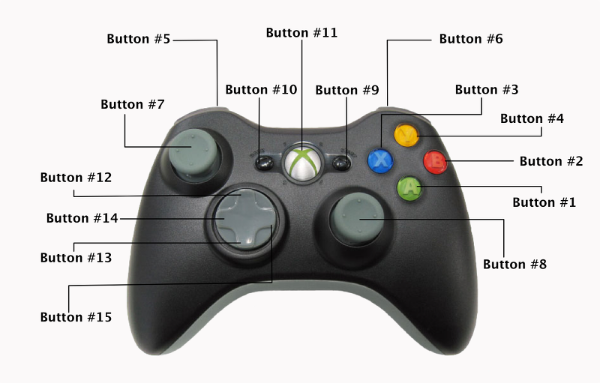

1. A Button – Elemental attack
2. B Button – Heavy attack
3. X Button – Light attack
4. Y Button – Medium attack
5. Left Bumper – Toggle input display
6. Right Bumper – Toggle input display
7. Left Joystick – Movement and directional input
8. Right Joystick – Unassigned
9. Start Button – Pause menu
10. Back Button – Unassigned
11. Home Button – Unassigned
12. – 15. D-Pad – Movement and directional input

# Basic Rules

**Setup:** In the versus game mode, the player will face off against a friend (or enemy!) in a three-round match. Each player with pick their character and element of choice and proceed to the stage.

**Victory:** The player who wins two of the three rounds is the victor, with a tie being a rare case.

**Draw:** If both players end the round with an equal amount of life, that round is declared a draw. Neither player wins, and the match continues

**Note!** If you are new to the game, the tutorial may be a fitting tool to help you understand the controls of the game. If you understand the base mechanics but are trying out a new character or element for the first time, the training mode will allow you all the time you want to hone your skills.

# Battle Interface

While in battle there are many aspects of the game to keep track of. Lucky for you, we have tools for just such an occasion! The battle interface shows the players all the information they need to know, from the health bars to the time left in the round.

(Insert picture of Battle Interface here)

**Timer:** At the top center of the screen lies the timer, this little gadget allows the players to know how much time is left in the round. This knowledge is important to know if you need to finish the opponent off before the end of the round.

**Health Bars:** These keep track of both players’ health. Depleting your opponent's health bar is the way to obtaining victory. Should the time run out in a round, the player with the highest amount of life left wins.

**Super Meter:** To perform your super moves, you must first fill your super meter. This is done by charging, and by dealing and receiving damage. Charging locks you in place and prevents any movement so it is a dangerous way to gain meter but worth it if you can find the chance.

**Character Portraits:**  These reside adjacent to the character’s health bar and denote which character you have chosen to play this match. What element each player has chosen is also noted close to the character portrait.

**Combo Counter:** Keeps track of how many times you’ve hit an opponent in a row.